1. What is the distribution of account balances across different regions?

Ans :

Above chart explains the distribution of account balances in different regions. France has highest account balance(311M) AND Spain has the lowest account balance(153M)

1. Identify the top 5 customers with the highest Estimated Salary in the last quarter of the year. (SQL)

Ans: Type of `Bank DOJ` column is text & it is in ‘DD-MM-YYYY’ format. To change it to date format I add a new column called `Bank_DOJ_UPDATED`.

Query to add column :

alter table bankcrm.customerinfo

add column Bank_DOJ_UPDATED DATE

Then update the `Bank_DOJ_UPDATED`. Column using data from initial `Bank DOJ` column.

Query to update column:

UPDATE bankcrm.customerinfo

SET Bank_DOJ_UPDATED = STR_TO_DATE(`Bank DOJ`, '%d-%m-%Y')

* Filters data for customers who joined in the fourth quarter

‘where extract (quarter from Bank_DOJ_UPDATED) = 4’

* Orders the results by estimated salary in descending order (ORDER BY estimatedsalary DESC)
* Restricts the output to the top 5 customers (LIMIT 5)

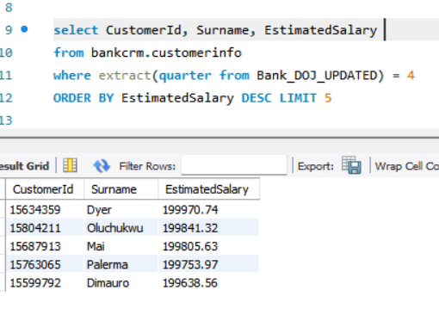

1. Calculate the average number of products used by customers who have a credit card. (SQL)

Ans:

* Filters data for customers who have a credit card (WHERE HasCrCard = 1)
* Computes the average number of products for these customers AVG(NumOfProducts)
* Assigned an alias (avgPrCrCard) to compute result with clarity

1. Determine the churn rate by gender for the most recent year in the dataset.

Ans:

From the above chart I can say that for most recent year(2019) churn rate for male is 15.37% and churn rate for female is 25.05%.

1. Compare the average credit score of customers who have exited and those who remain. (SQL)

**Ans:**

* Customers exited the bank are defined by 1 and remain within the bank are referred by 0 in the Exited Column.
* Groups data by customer exit status (GROUP BY Exited)
* Calculates the average credit score for each group (AVG(CreditScore))
* Assigns aliases for clarity (avgCreditScore)

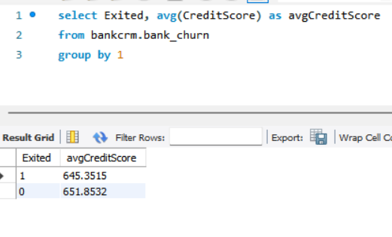

1. Which gender has a higher average estimated salary, and how does it relate to the number of active accounts? (SQL)

Ans: Query to get the answer

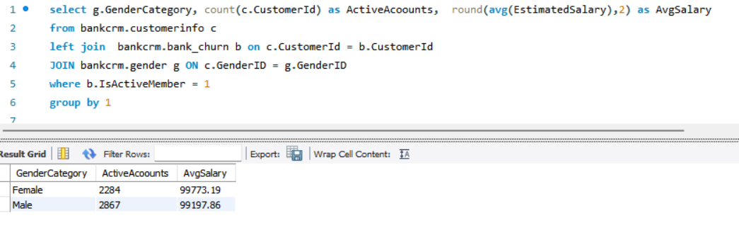

Female has less active accounts but higher average salary but Male has more active accounts but lesser average salary.

1. Segment the customers based on their credit score and identify the segment with the highest exit rate. (SQL)

**Ans:**  Below mentioned query employs a Common Table Expression to classify customers into Multiple segments base on Credit score.

This is the classification

CreditScore between 401 and 500 then 'Poor'

when CreditScore between 501 and 600 then 'Fair'

when CreditScore between 601 and 700 then 'Good'

when CreditScore between 701 and 800 then 'Very Good'

when CreditScore > 800 then 'Excellent'

Exit rate is calculated by below formula

Formula = (Total exit per segment / Total exit) * 100

Result is grouped by CreditSegment and Order by ExitRate in descending order

Used Limit 1 to display the highest exit rate.

1. Find out which geographic region has the highest number of active customers with a tenure greater than 5 years. (SQL)

**Ans:** This query retrieves geographic region which has the most number of active customers who has a tenure of more than 5 years.

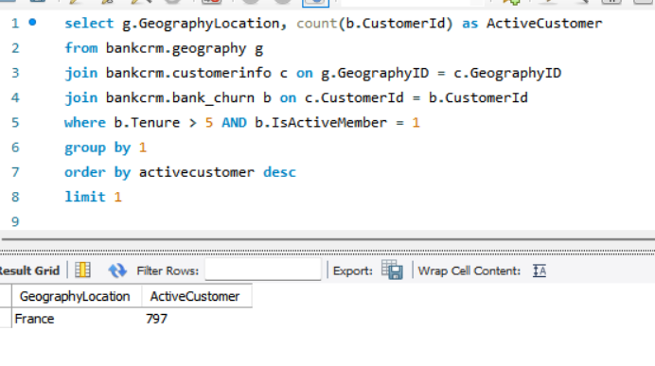

1. **What is the impact of having a credit card on customer churn, based on the available data?**

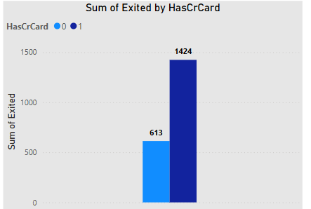**Ans:**

From the above chart it is clearly visible that customers with credit card has high churning rate.

1. **For customers who have exited, what is the most common number of products they have used?**

**Ans:**  From below chart I can say that for customers who have exited the most common number of products they have used is 1. 1409 customers have used this product.

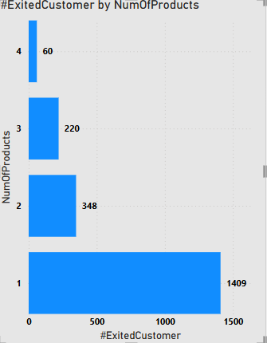

1. **Examine the trend of customers joining over time and identify any seasonal patterns (yearly or monthly). Prepare the data through SQL and then visualize it.**

**Ans:** Following sql query will give us the required data

1. **Analyse the relationship between the number of products and the account balance for customers who have exited.**

**Ans:**

From above graph I can say that customers who have used 4 number of products have lowest amount of balance i.e. 6M. At the same time customers who have used 1 number of product have highest balance which is 130M.

1. **Identify any potential outliers in terms of balance among customers who have remained with the bank.**

**Ans:** To identify potential outliers in terms of balance among customers who have remained with the bank below steps are taken.

1. Calculate the mean of balance (72.75K) for customers who have remained with the bank.
2. Calculate the 2 standard deviations i.e. 125.69K to find the dispersion
3. For outlier threshold I have used 2nd standard deviation. As our minimum balance is 0, I have considered only the upper threshold (Mean + 2nd Standard deviation) i.e. 198.44k
4. Any amount greater than 198.44k is considered as outlier.

Below table shows details of customers who are potential outlier

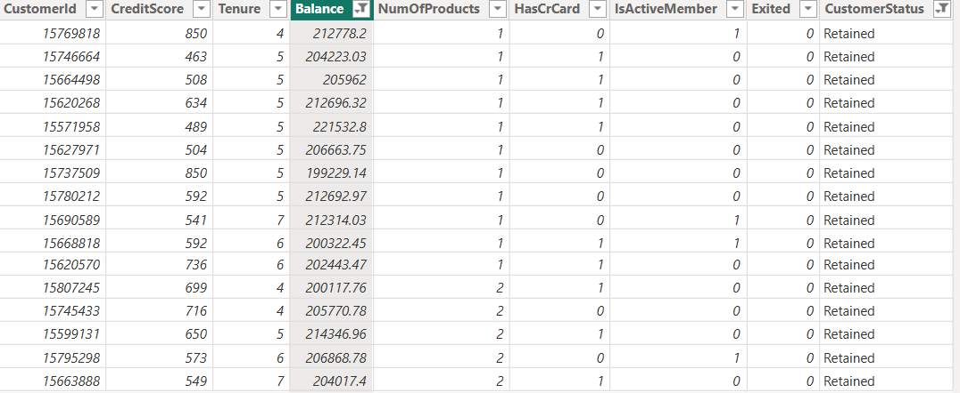

1. **How many different tables are given in the dataset, out of these tables which table only consists of categorical variables?**

Ans: In the dataset, there are 7 tables. Among these 6 tables contains categorical variables.

* In activecustomer table ActiveCategory is categorical variable.
* In customerifo table categorical variables are surname, genderID, geographyID
* In creditcard table Category is categorical variable.
* In exitcustomer table ExitCategory is categorical variable.
* In gender table GenderCategory is categorical variable.
* In geography table GeographyLocation is categorical variable.

1. **Using SQL, write a query to find out the gender-wise average income of males and females in each geography id. Also, rank the gender according to the average value. (SQL)**

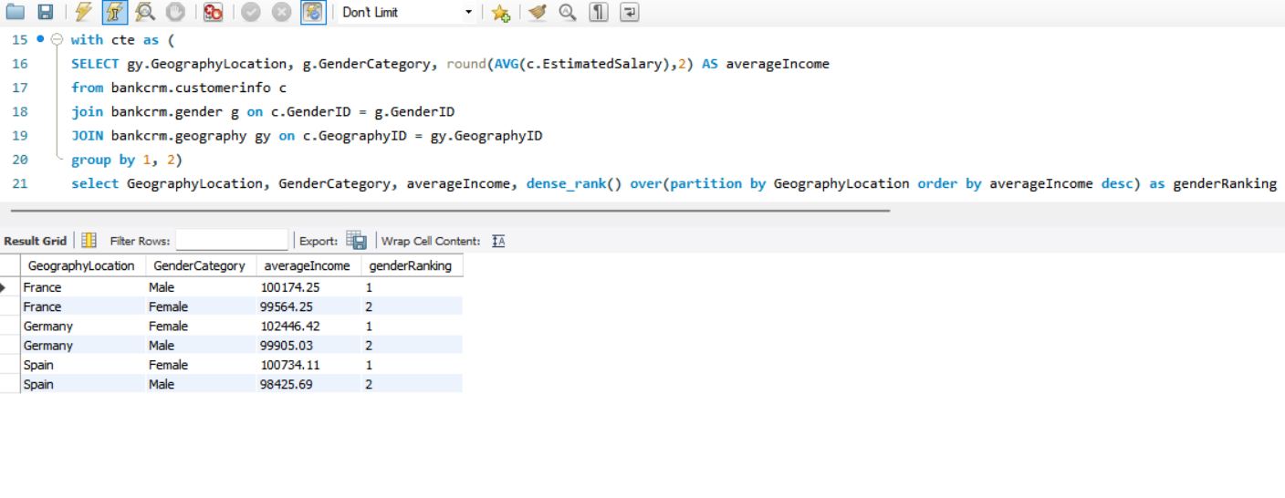**Ans:** Below sql code computes gender wise average income for each location and also rank gender based on average income.

1. Using SQL, write a query to find out the average tenure of the people who have exited in each age bracket (18-30, 30-50, 50+).

Ans: Below SQL query computes average tenure of customers who have exited for each age bracket. Age 18-30 is considered as young, 30-50 considered as MiddleAged, 50+ considered as Old

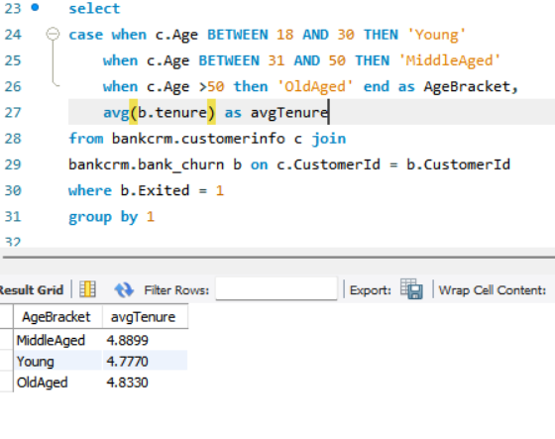

1. **Is there any direct correlation between salary and the balance of the customers? And is it different for people who have exited or not?**

**Ans:** No correlation found between salary and balance. This absence of correlation is consistent with both retained and exited customer.

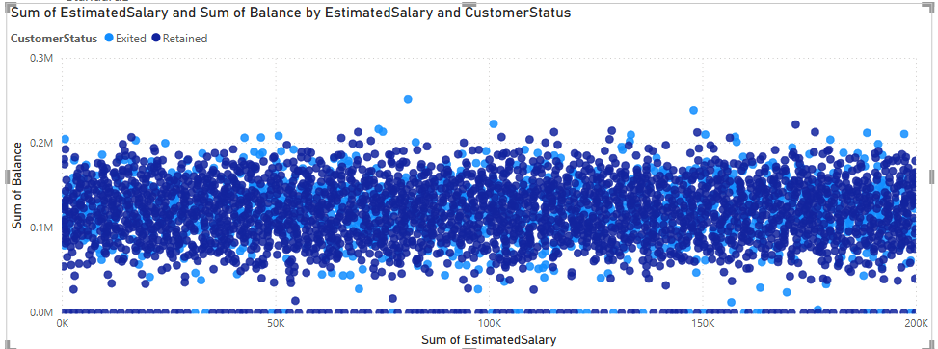

1. **Is there any correlation between the salary and the Credit score of customers?**

**Ans:** No correlation found between credit score and estimated salary. Salary may impact the credit limit but there is no direct correlation between credit score and estimated salary.

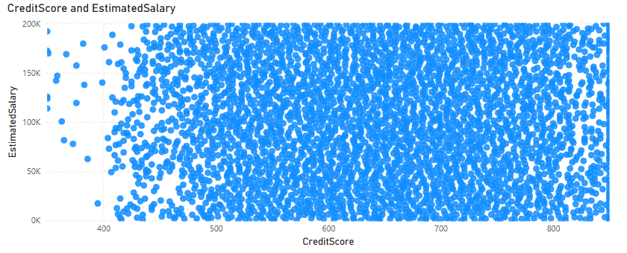

1. **Rank each bucket of credit score as per the number of customers who have churned the bank.**

**Ans:**

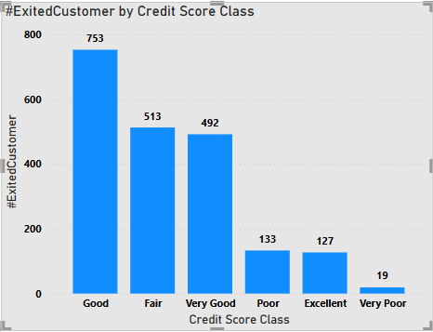

**Classification of customers based on credit score**

Credit Score between 401 and 500 then 'Poor'

when credit Score between 501 and 600 then 'Fair'

when credit Score between 601 and 700 then 'Good'

when credit Score between 701 and 800 then 'Very Good'

when credit Score > 800 then 'Excellent'

If I rank each bucket of credit score, then” Good” will be ranked 1 with a churning of 753

“Fair” will be ranked 2 with a churning of 513

“Very Good" will be ranked 3 with a churning of 492

“Poor” will be ranked 4 with a churning of 133

“Excellent” will be ranked 5 with a churning of 127

“Very poor" will be ranked 6 with a churning of 19

1. **According to the age buckets find the number of customers who have a credit card. Also retrieve those buckets that have lesser than average number of credit cards per bucket.**

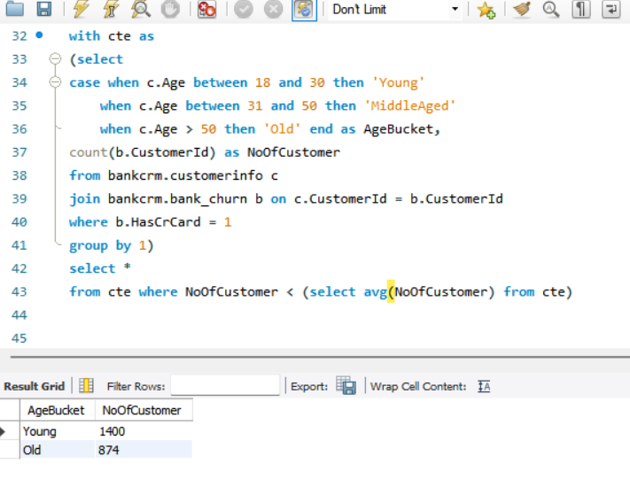**Ans:** SQL code retrieves age buckets that have lesser than average number of credit cards per bucket. Age 18-30 is considered as young, 30-50 considered as MiddleAged, 50+ considered as Old. Filters for customers with credit cards (HasCrCard = 1)

1. Rank the Locations as per the number of people who have churned the bank and average balance of the customers.

**Ans:** To find the ranking of locations based on churning and Average balance below steps are taken

1. Created a measure called “Churned Customer By Location”
2. Created another measure called “Average Balance Per Location”
3. Created a measure called “Rank by churning “to find churning wise rank per location.
4. Created a measure called “Rank by average balance” to find average balance wise ranking per location.
5. Finally create a measure called “Overall Ranking” to rank locations based on both churning and average balance.

1. **As we can see that the “CustomerInfo” table has the CustomerID and Surname, now if we have to join it with a table where the primary key is also a combination of CustomerID and Surname, come up with a column where the format is “CustomerID_Surname”.**

**Ans:** I have done that in my data model by using below DAX formula

CustomerID_Surname = CustomerInfo[CustomerId] & "_" & CustomerInfo[Surname]

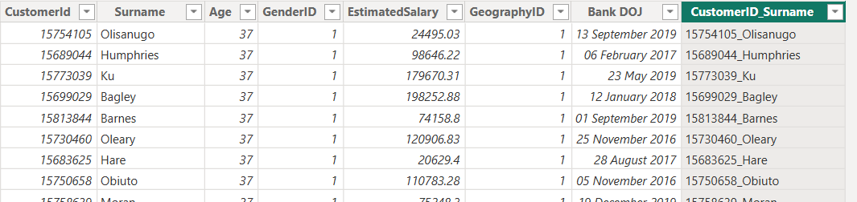

1. **Without using “Join”, can we get the “ExitCategory” from ExitCustomers table to Bank_Churn table? If yes do this using SQL.**

**Ans:** Below SQL query retrieves data from Bank_Churn table and add a new column called ExitCategory using Exited column. If Exited = 1 then Exit else Retain

1. **Were there any missing values in the data, using which tool did you replace them and what are the ways to handle them?**

**Ans:** In our data there are no missing values.

If there are missing values, I would have used Power Query to handle those missing values.

Ways to handle missing values

* Remove rows or columns with missing values. This technique is useful when missing values are minimal.
* Replace missing values with calculated values like mean, median, mode or KNN
* Use statistical model like Decision tree or Random Forest that can handle missing values.

1. Write the query to get the customer IDs, their last name, and whether they are active or not for the customers whose surname ends with “on”.

**Ans:** Below SQL code extracts customerid, surname & active status

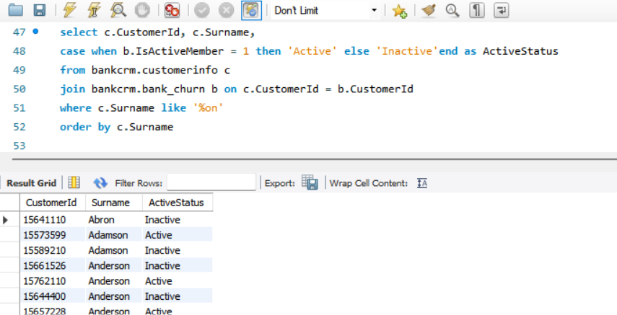

1. **Can you observe any data disrupency in the Customer’s data? As a hint it’s present in the IsActiveMember and Exited columns. One more point to consider is that the data in the Exited Column is absolutely correct and accurate.**

**Ans:**

From below chart It is clearly visible that there are 735 customers who already exited but still their status is 1 in IsActiveMember column. If we consider that Exited Column data is absolutely correct then these 735 customers Active status is incorrect.

**Subjective Questions**

* 1. Customer Behavior Analysis: What patterns can be observed in the spending habits of long-term customers compared to new customers, and what might these patterns suggest about customer loyalty?

Ans:

Customers who have joined in the year of 2019 are considered as new customers and rest are considered as old customers.

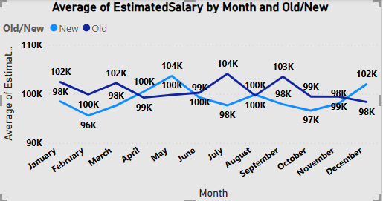

Above chart shows month wise Estimated salary trend for old and new customers.

* Old customers maintained comparatively higher salary than new customers for most of the time
* Long term trend suggests that salary of old customers is slightly decreasing whereas salary of new customers is slowly increasing.
* Average salary for Old and New diverged the most when the Month was July

* Average balance for new customers fluctuates comparatively more than old customers. Average balance for new customers reached the lowest point(69k)
* Average balance for old customers is slightly stable.
* Divergence between old and new customers is highest in the month of February.
* A graph with blue lines and numbers

  Description automatically generatedNew customers used a greater number of products than old customers.
* Number of products held by old customers are stable
* Number of products held by new customers fluctuate a lot and is on an increasing trend.

1. Product Affinity Study: Which bank products or services are most commonly used together, and how might this influence cross-selling strategies?

Ans:

Commonly paired bank products

* Checking & saving accounts
* Credit cards & checking accounts
* Loans & insurance products
* Investment products & saving accounts

Influence on cross selling strategies

* 1. **Personalized offer:** By understanding which products are commonly used together, banks can create personalized offers that cater to individual customer needs.
  2. **Customer experience:** Cross-selling complementary products can enhance the overall customer experience by providing a comprehensive suite of financial solutions. This can lead to higher customer satisfaction & loyalty.
  3. **Increase revenue:** Effective cross-selling strategies can significantly increase revenue by encouraging customers to use multiple products and services. This not only boost sales but also improves customer retention.
* Unfortunately, our data does not contain this product information except credit card. Provided data is not enough to do affinity study for products like insurance, loans, investment products, savings & checking accounts. Hence it is not possible to find influence of cross-selling strategies.

1. 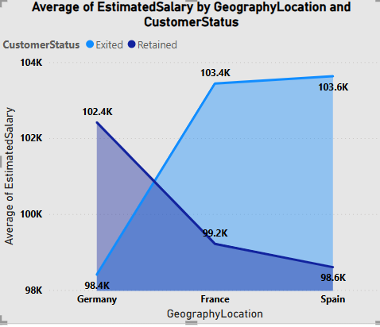**Geographic Market Trends: How do economic indicators in different geographic regions correlate with the number of active accounts and customer churn rates?**

Ans:

Average salary by geographic location

* In Germany retained customers have a high salary whereas exited customers have low salary which indicates that higher salary leads to lower churn
* But these does not seem true for France & Spain. In these 2 countries exited customers have higher salary. From this insight I can say that In France and Spain high earning customers are not satisfied with the bank.

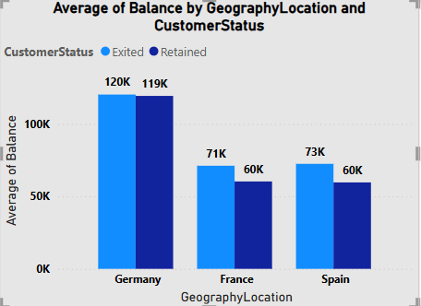Average balance by geographic location

* From the chart it is clear that average balance for retained customers is lower than exited customers.
* In France & Spain divergence is significantly higher

Average credit score by geographic location

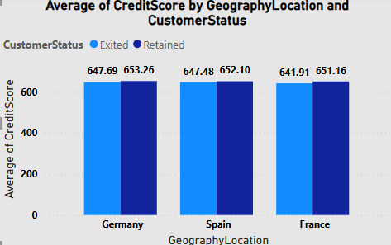

* Chart shows variation in credit score for different geographic locations with a bifurcation of exited & retained customers.
* In all 3 location exited customers have lower credit score.

1. Risk Management Assessment: Based on customer profiles, which demographic segments appear to pose the highest financial risk to the bank, and why?

Ans:

* Rich & higher middle class have a high salary, but poor & lower middle class have a very low salary.
* Most rich & higher middle-class customers come under Good, excellent & very good credit score bucket. At the same time most poor & lower middle-class customers come under fair & poor credit score bucket.
* From above 2 charts I can reach to the conclusion that poor & lower middle-class customers pose maximum financial risk to the bank.

1. 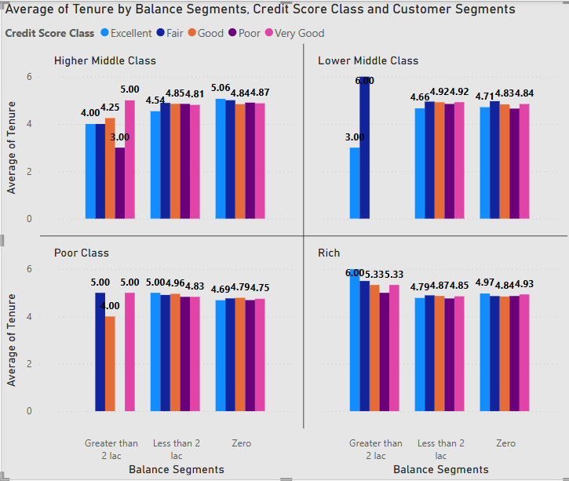**Customer Tenure Value Forecast: How would you use the available data to model and predict the lifetime (tenure) value in the bank of different customer segments?** Ans:

From the above chart below insights are found

* Across all class customers with balance greater than 2 lacs have comparatively high tenure. As for example among Rich class customers with balance greater than 2 lacs have highest tenure of 6 years. Among other class also I find the same thing.
* Through out all classes customers who belongs to poor credit score bucket have lowest tenure. Customers with a very good or excellent credit score have highest tenure across all classes.
* Among all classes rich segment has slightly higher tenure whereas poor segment has comparatively lower tenure.

Prediction of tenure for each customer segment

For rich segment tenure will be 5.5 to 6 years

For higher middle class tenure will be 5 to 5.5 years

For lower middle class tenure will be 5 to 5.25 years

For poor class tenure will be 4.8 to 5 years

1. **Marketing Campaign Effectiveness: How could you assess the impact of marketing campaigns on customer retention and acquisition within the dataset? What extra information would you need to solve this?**

Ans:

Assessing the impact of marketing campaigns on customer retention and acquisition involves several steps.

**1. Define Key Metrics**

Identify the key performance indicators (KPIs) that will help you measure the effectiveness of your campaigns. Common metrics include:

* **Customer Acquisition Rate**: Number of new customers acquired during the campaign period.
* **Customer Retention Rate**: Percentage of existing customers retained during the campaign period.
* **Customer Lifetime Value (CLV)**: The predicted net profit from the entire future relationship with a customer.
* **Churn Rate**: The percentage of customers who stop using your product or service during a given time frame.
* **Conversion Rate**: The percentage of users who take a desired action, such as making a purchase.

**2. Segmentation**

Segment your customers into different groups based on their behavior, demographics, or other relevant criteria. This helps in understanding which segments are most influenced by the campaign.

**3. Pre- and Post-Campaign Analysis**

Compare the metrics before and after the campaign to assess its impact. For example:

* **Customer Acquisition**: Compare the number of new customers acquired before and after the campaign.
* **Customer Retention**: Analyze the retention rate before and after the campaign to see if there’s an improvement.

**4. Control Groups**

Use control groups to isolate the effect of the campaign. A control group is a set of customers who are not exposed to the campaign. Comparing their behaviour with those who were exposed to the campaign can provide insights into the campaign’s effectiveness.

**5. Statistical Analysis**

Apply statistical methods to determine the significance of the changes observed. Techniques such as A/B testing, regression analysis, and hypothesis testing can be useful.

Extra information I would need to solve this:

* Customer Acquisition Rate
* Conversion Rate
* Data on customer interactions before, during and after the campaign
* Competitor data to do comparison with other bank
* Customer demographics, macroeconomics data

1. **Customer Exit Reasons Exploration: Can you identify common characteristics or trends among customers who have exited that could explain their reasons for leaving?**

Ans:

From the above chart it is clearly visible that customers who have credit card has high churning rate. Customers without credit card has low churning rate. Among exited customers 69.91% are credit card holders.

Above chart illustrates churned customers by number of products used. Customers who have used only one product are responsible for maximum churning. Minimum churning shown in customers who are using all 4 products. Form the chart I can say that when a greater number of products are used by customers churning rate reduced. Multiple product users find more value in their relationship with the bank. To reduce churning rate customers should be pushed to use multiple products.

1. **Are 'Tenure', 'NumOfProducts', 'IsActiveMember', and 'EstimatedSalary' important for predicting if a customer will leave the bank?**

Ans:

Above chart shows churned customers by tenure. From the chart insights that I am getting is customers with a tenure of 4, 5 & 6 years have high churning. Whereas customers with a tenure of more than 6 years have lower churning. As tenure increase churning decrease.

Therefore, I can say that tenure is an important metric to predict customer churning.

Above chart illustrates churned customers by number of products used. Customers who have used only one product are responsible for maximum churning. Minimum churning shown in customers who are using all 4 products. Form the chart I can say that when a greater number of products are used by customers churning rate reduced. Multiple product users find more value in their relationship with the bank. To reduce churning rate customers should be pushed to use multiple products.

Again, Number of products can be considered as another important metric to predict churning.

Active Member Status: My analysis mostly focuses on active customers. Importance of active member status not as much as other metrics

Chart shows insight for churning across multiple salary classes. Churning has happened across all salary classes. But churning in High salary class is comparatively higher. Among low salary class churning is lower. So, I can consider Estimated salary an important metric to predict if a customer will leave bank or not.

1. Utilize SQL queries to segment customers based on demographics and account details.

Ans:

* 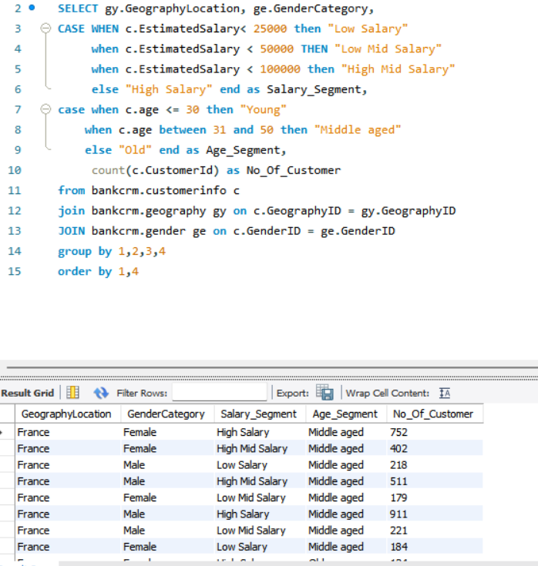Above sql query join customerinfo table with geography and gender table.
* It does two segmentation. One is salary wise segmentation and secondly age wise segmentation.
* For each segment number of customers are calculated.
* Result is ordered by firstly location and then by age segment.

1. How can we create a conditional formatting setup to visually highlight customers at risk of churn and to evaluate the impact of credit card rewards on customer retention?

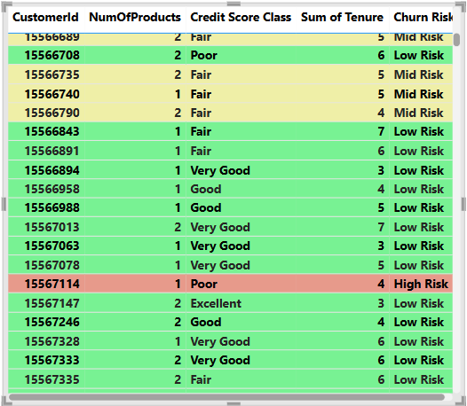Ans :

Factors considered to define risk of churning

* If number of products < 2 and tenure<= 4 and credit score class = Poor, then High Risk
* If number of products <= 3 and tenure<= 5 and credit score class = Fair, then Mid Risk
* Else for all other scenario low risk

Based on these conditions I have created a new column called Churn Risk in my data model.

In the report I have created a table visual with the following columns

CustomerID, Number of products, Credit score class, Tenure& Churn Risk

Apply conditional formatting on all the columns-based om Churn Risk. If Churn Risk is low, then row colour will be green. If Churn Risk is Mid, then row colour will be yellow. If Churn Risk is high, then row colour will be red.

Number of High-Risk customers: 148

Number of Mid Risk customers: 1614

Number of Low-Risk customers: 8238

Impact of credit card on retention of customers

Create a measure called retained customer that counts number of retained customers

**#Retained Customer = CALCULATE(COUNT(Bank_Churn[CustomerId]),Bank_Churn[CustomerStatus] = "Retained")**

Create another measure called retained customer with credit card that counts number of retained customers with credit card.

**#Retained Customer with credit card = CALCULATE(COUNT(Bank_Churn[CustomerId]),Bank_Churn[CustomerStatus] = "Retained" && Bank_Churn[HasCrCard] = 1)**

Finally create a KPI called “% of Retained customers with credit card”

**%ofRetained customers with credit card = DIVIDE([#Retained Customer with credit card],[#Retained Customer])**

This KPI should be monitored to track impact of credit card rewards on customer retention. Increase in KPI value indicates that credit card rewards are effecting to reduce churning.

1. What is the current churn rate per year and overall as well in the bank? Can you suggest some insights to the bank about which kind of customers are more likely to churn and what different strategies can be used to decrease the churn rate?

ANS:

* A graph of blue rectangular bars

  Description automatically generated with medium confidenceOverall churn rate for the bank is 20.37%

From the above chart I can say that

* Churning rate for 2016 is 19.27%
* Churning rate for 2017 is 22.35%
* Churning rate for 2018 is 20.21%
* Churning rate for 2019 is 19.86%

**Customers prone to churn**

* **Single Product Use**: Customers using only one product from a bank may find less value compared to competitors with more offerings.
* **Credit Card Issues**: Limited credit limits, lack of rewarding programs, and high fees can deter card retention.
* **Credit score issue** : Among credit card holders customers with low credit score are prone to churn.
* **Tenure of 4-5 Years**: Customers nearing the end of introductory offers may be tempted by better terms from competitors.
* **High Salary**: High-income earners might switch banks for slightly better rates or benefits.

**Recommendations to reduce customer churn**

* **Digital Engagement and Personalization**: Utilize data analytics to offer personalized digital experiences. This includes personalized financial advice, customized product recommendations, and proactive alerts for financial opportunities or risks. Enhancing the digital experience can increase customer satisfaction and loyalty.
* **Enhanced Credit Card Rewards**:
  + Increase credit limits based on customer history and creditworthiness.
  + Offer rewards that match spending habits (e.g., travel rewards, cash back).
  + Reduce or waive annual fees for high-value customers.
* **Targeted Product Bundles**: Develop tailored bundles for specific customer segments to highlight added benefits and cost savings.
* **Retention Offers**: Provide personalized retention deals to customers nearing the end of introductory offers.
* **Relationship Management**: Assign dedicated managers to high-value customers for personalized service and exclusive benefits.
* **Customer Satisfaction Surveys**: Conduct regular surveys to understand churn reasons and improve retention strategies.

1. Create a dashboard incorporating all the KPIs and visualization-related metrics. Use a slicer in order to assist in selection in the dashboard.

Ans:

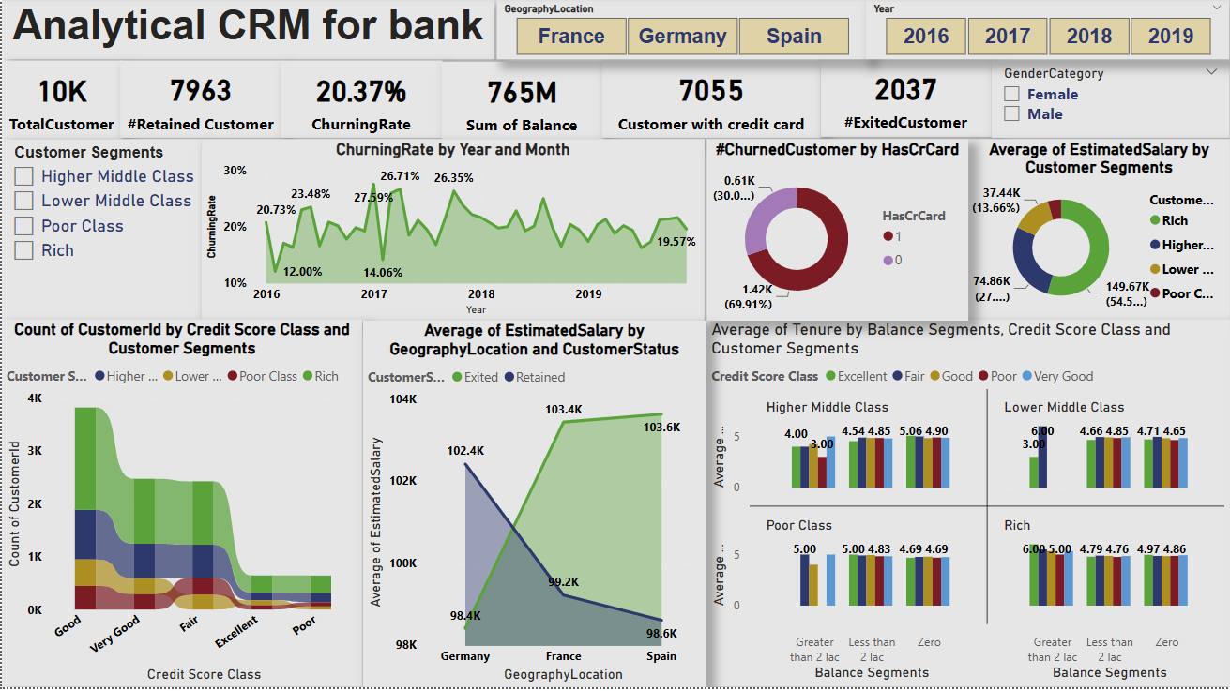

1. How would you approach this problem, if the objective and subjective questions weren't given?

**Ans:**

**Hypothesis Generation:**

This is the initial phase where I generate possible explanations or assumptions about the data and the problem based on prior knowledge or observations. These hypotheses guide the investigation and help focus the analysis.

* + **Customer Churn**: Assume certain factors, such as age, income, or account balance, may be linked to a higher likelihood of customer churn. For instance, you might hypothesize that younger customers with lower balances are more likely to leave.
  + **Marketing Campaign**: Hypothesize that social media ads perform better than email marketing in terms of engagement for a younger demographic, or that higher ad spend doesn’t always lead to proportional performance improvements.

**2. Question Formulation:**

Once I have hypotheses,I formulate specific, data-driven questions that will guide your analysis. These questions should be designed to validate or refine your hypotheses by focusing on measurable factors within your data.

* **Examples for Customer Churn Analysis**: a. **Are there demographic patterns associated with churn?** - This could reveal if certain age groups or income levels are more prone to leaving. b. **Does the number of products held by a customer influence churn?** - Perhaps customers who hold more products (like loans, credit cards) are more loyal. c. **How does customer activity (transactions, logins) correlate with churn?** - This could show if decreasing activity is an early warning sign of churn.
* **Examples for Marketing Campaign Analysis**: a. **Which marketing channels are most effective at reaching target audiences?** - Aimed at understanding if email marketing, social media, or direct mail is more successful. b. **Is there a correlation between ad spend and campaign performance?** - Can help identify if more spending leads to proportionally better results or if certain campaigns underperform despite higher spend. c. **How does campaign messaging impact customer engagement and conversion rates?** - Examining which messages (e.g., discounts, product launches) drive the most engagement or conversions.

**3. Data Exploration and Analysis:**

This step involves diving into the data using visualization tools and statistical methods to answer the questions formulated in the previous step. It’s where you test the hypotheses, discover patterns, and validate assumptions.

* **Techniques to use**:
  + **Visualizations**: Charts (bar, line, scatter plots), heat maps, and slicers to make patterns visible.
  + **Statistical Analysis**: Correlation analysis to check the strength of relationships (e.g., between churn rate and account balance), and regression analysis to predict trends (e.g., how ad spend affects campaign outcomes).
  + **Segmentation**: Group customers by demographics, product usage, or behaviour to see how different segments act.
* **Examples**:
  + **Customer Churn**: Visualize churn rates by demographic (age, income) and look for patterns. Analyse how the frequency of customer logins or transactions impacts churn.
  + **Marketing Campaign**: Compare performance across channels (e.g., email, social media) using a bar chart to see where engagement is highest. Use scatter plots to visualize the relationship between ad spend and conversion rates, identifying diminishing returns on certain campaigns.

**4. Insights and Recommendations:**

Once data exploration is complete, I will interpret the findings and provide actionable recommendations. This step is crucial for turning raw data into practical insights that inform business decisions.

* **How to apply it**:
  + **Customer Churn**: If the data shows that younger customers with lower balances are more likely to churn, you might recommend targeted loyalty programs or offers to retain this group. If reduced activity is linked to churn, implementing proactive engagement strategies (like personalized emails) could help.
  + **Marketing Campaign**: If social media consistently outperforms email campaigns in engagement, shifting more resources to social channels may be beneficial. If spending more on ads doesn’t improve performance, reallocating the budget to more efficient channels or adjusting messaging could yield better results.

**Specific Applications of This Approach:**

**Customer Attrition Analysis:**

* **Demographic Patterns**: Visualizing churn by age, gender, or income group can highlight at-risk segments. For example, churn may be higher among lower-income customers or younger users.
* **Account Balance/Product Usage**: Analysing the relationship between account balances, number of products used, and churn can help banks identify customers who may be more loyal (those using multiple services) or at risk (those with low balances).
* **Customer Activity**: Monitoring login frequency or transaction history helps identify disengaged customers. Customers with declining activity might need targeted retention efforts before they churn.

**Campaign Effectiveness Analysis:**

* **Channel Effectiveness**: Use channel-based analysis to identify which platforms (email, social, phone) perform best for specific customer segments. For instance, younger audiences might respond better to social media campaigns.
* **Correlation Between Spend and Performance**: Ad spend data can be correlated with campaign outcomes to see if higher spending leads to proportionately better results. You might discover that certain channels or campaigns perform well with minimal spend, leading to more efficient budget allocation.
* **Messaging Impact**: Analysing different messaging strategies (e.g., product promotions vs. discount offers) helps determine which resonates most with customers and drives conversions.

**Outcome: Decision Making**

By following the steps of **hypothesis generation**, **question formulation**, **data exploration**, and **insights derivation**, I can arrive at actionable recommendations for:

* **Customer Behaviour**: Implementing retention programs or churn prevention strategies.
* **Marketing Strategies**: Optimizing ad spend and targeting the most effective channels.
* **Product Development**: Adjusting product offerings based on customer preferences and behaviours.

1. In the “Bank_Churn” table how can you modify the name of the “HasCrCard” column to “Has_creditcard”?

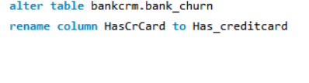Ans:

By using above query I can change the name of the "HasCrCard" column to "Has_creditcard" in the "Bank_Churn" table.